Competitive Shooters of Lake Norman USPSA February 13th, 2026
COURSE DESIGNER: Ike Starnes

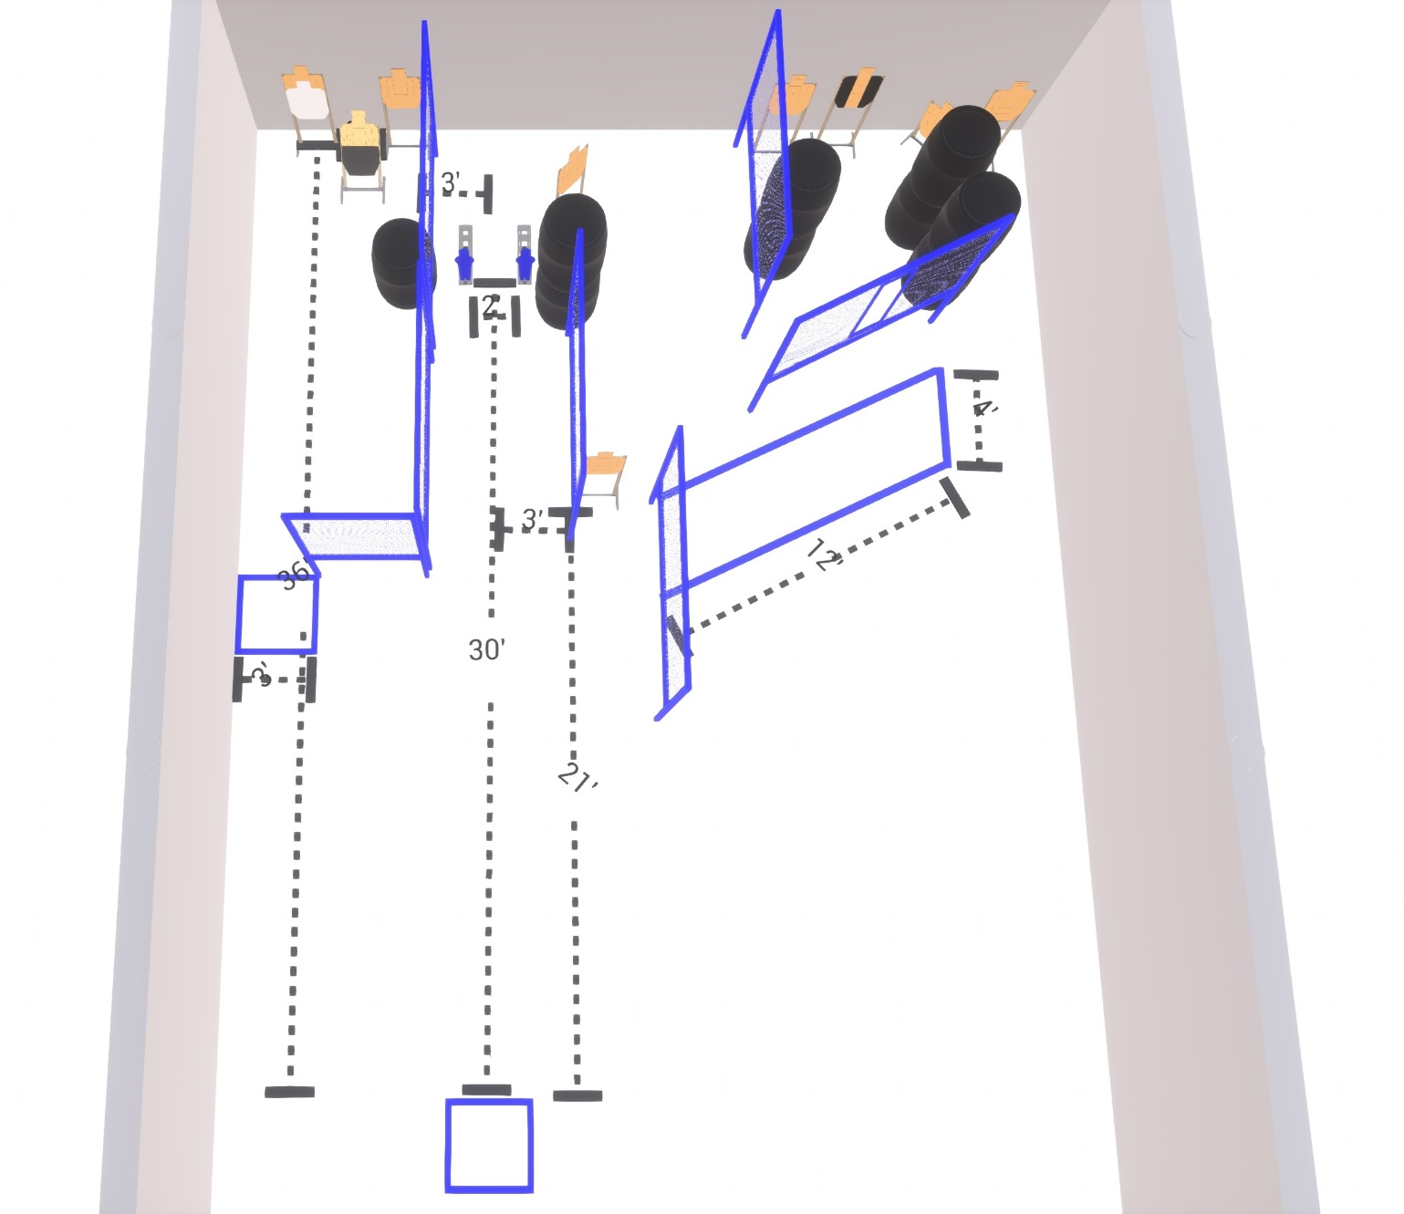

Stage 2 – May the luck of the Irish be with you
20 rounds, 100 points, Comstock
There are 9 cardboard targets with some no-shoots and 2 steel targets.
Starting inside the shooting area.
Handgun is loaded and holstered, wrists below belt.
PCC is loaded held in both hands, stock touching belt.
On the audible start signal, engage targets from within the shooting area.

